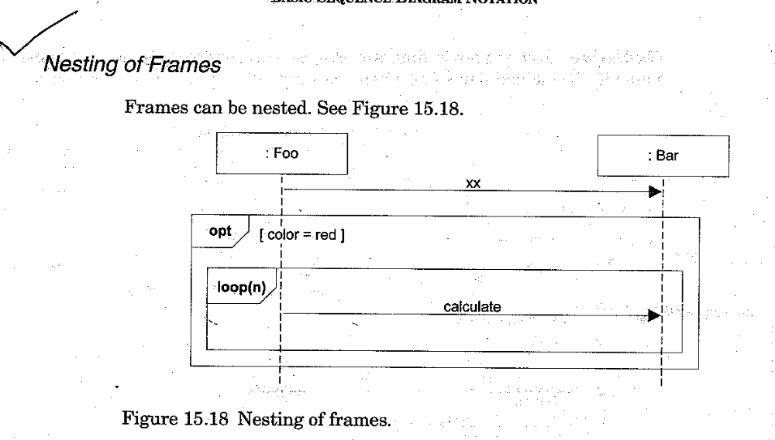

How to relate Interaction Diagram?
An interaction occurrence (interaction use) is reference to an interaction within another interaction.
When it is useful?
To simplify the diagram and factor out a portion into another diagram
If Reusable interaction occurs.

Two related frames
A frame around an entire sequence diagram :labeled with the tag sd and a name
A frame tagged ref (reference) refers to another name sequence diagram(It is the actual interaction occurrence

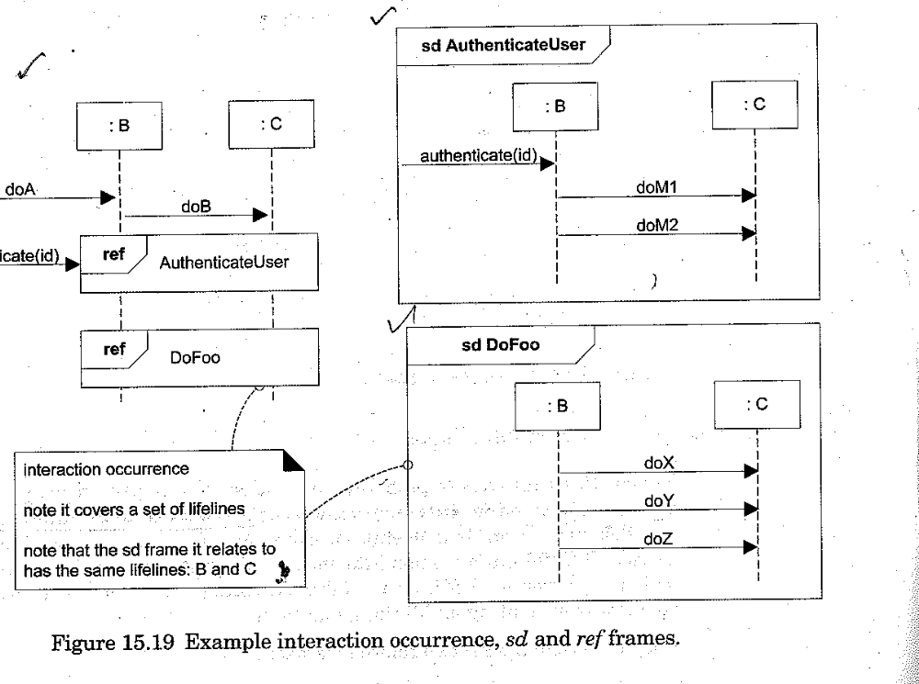

Messages to classes to invoke static or class methods

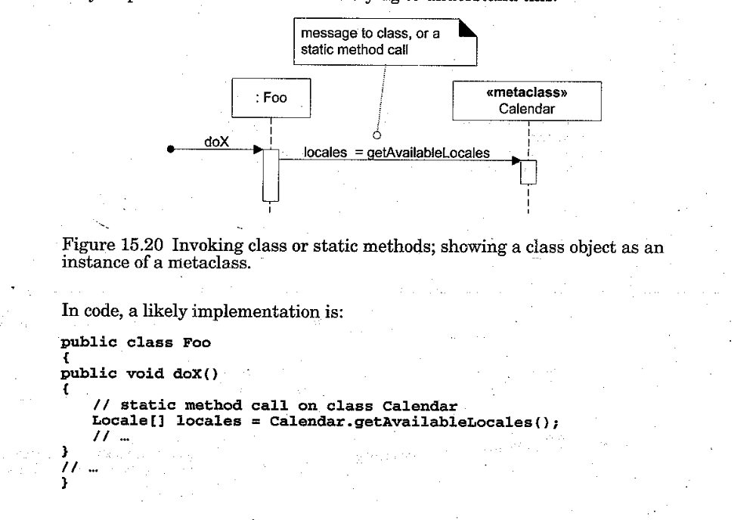

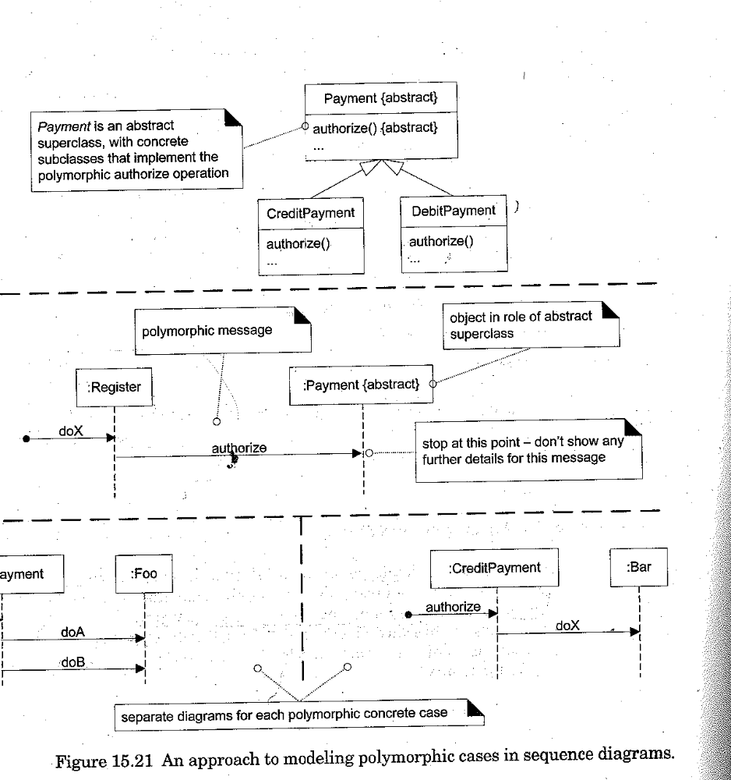

Asynchronous Calls-does not wait for a response.

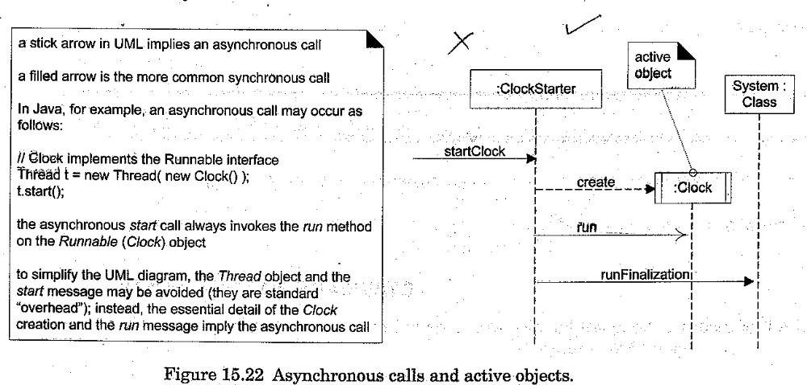

Interaction diagram-illustrate how objects interact via messages.used for dynamic object modeling.
Sequence diagram illustrate interaction in a kind of fence format in which each new object is added to the right.
Communication Diagram
Ilustrate object interactions in a graph or network format,in which objects can be placed anywhere on the diagram.

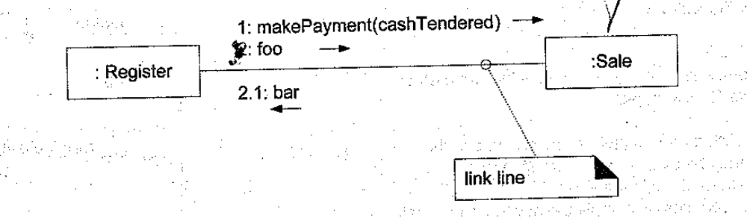
A link is a connection path between two objects .
It indicates some form of navigation and visibility between the objects is possible.
A link is an instance of an association.
Multiple messages can flow on the same line.
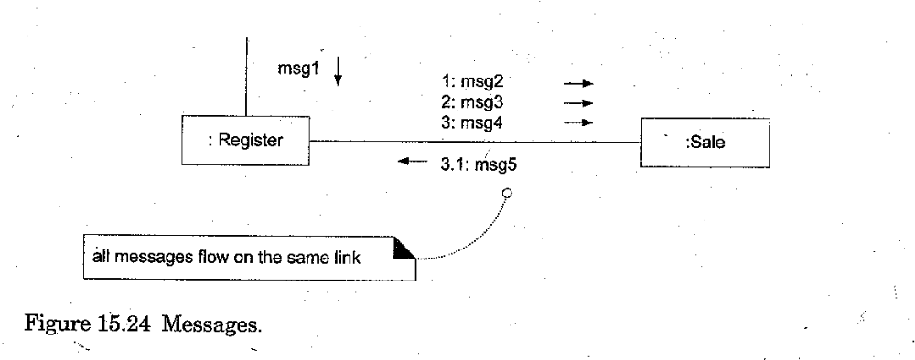

Creation of instance
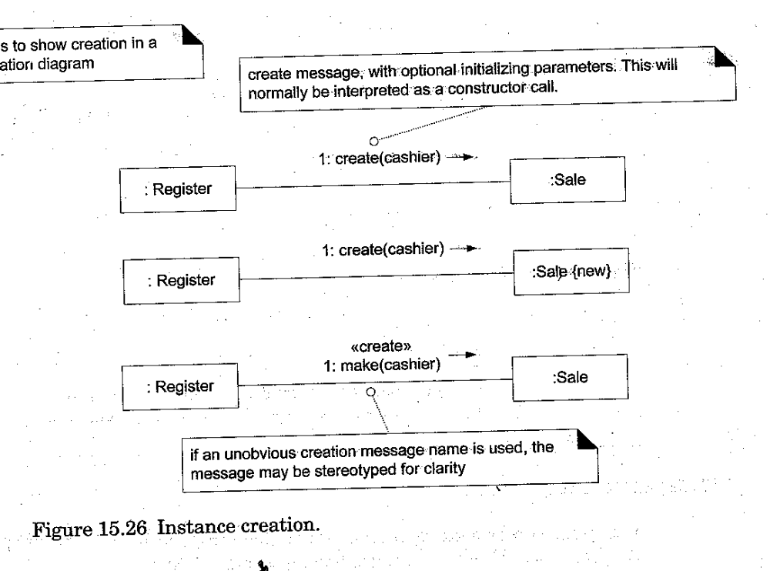

Message Number Sequencing

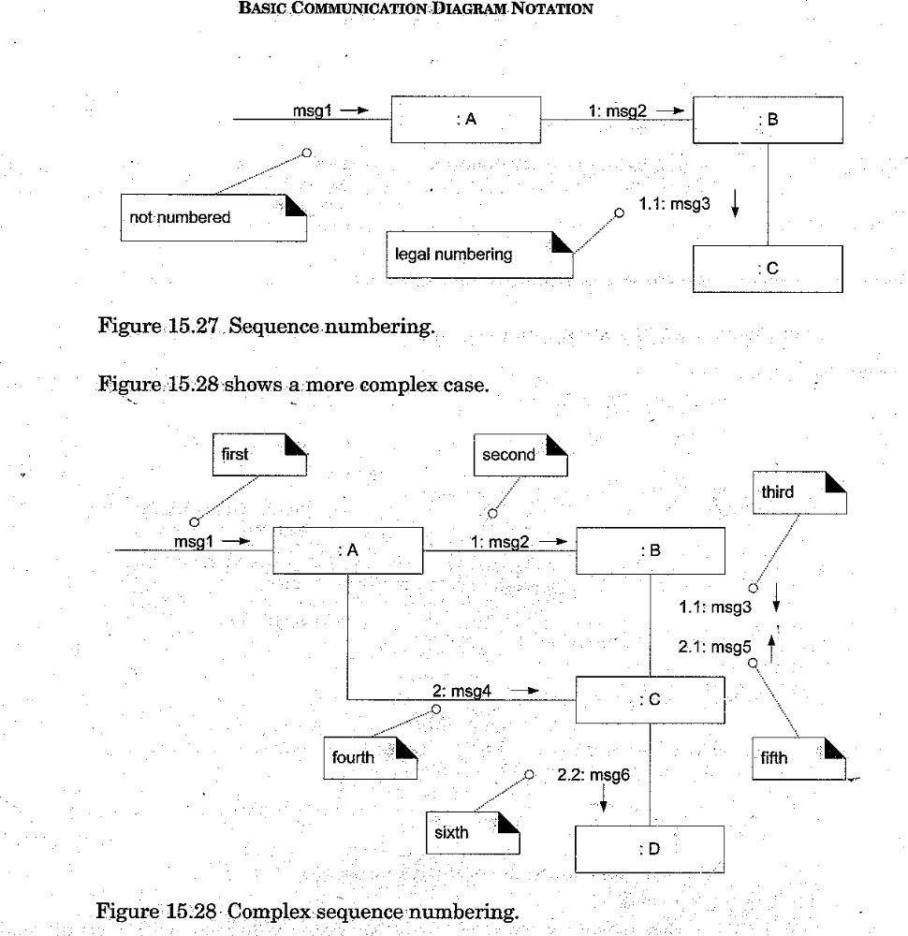

Conditional Messages.
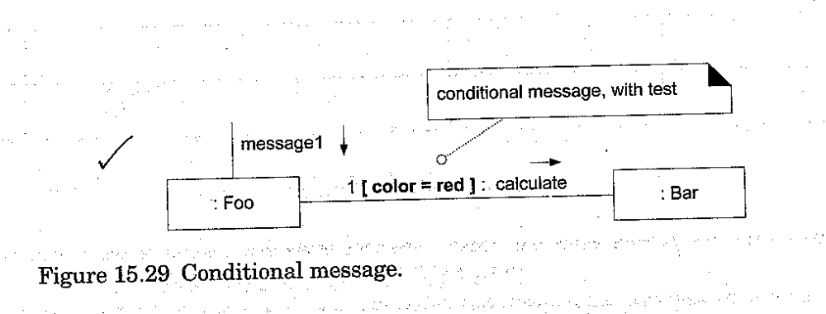

Mutually Exclusive conditional path

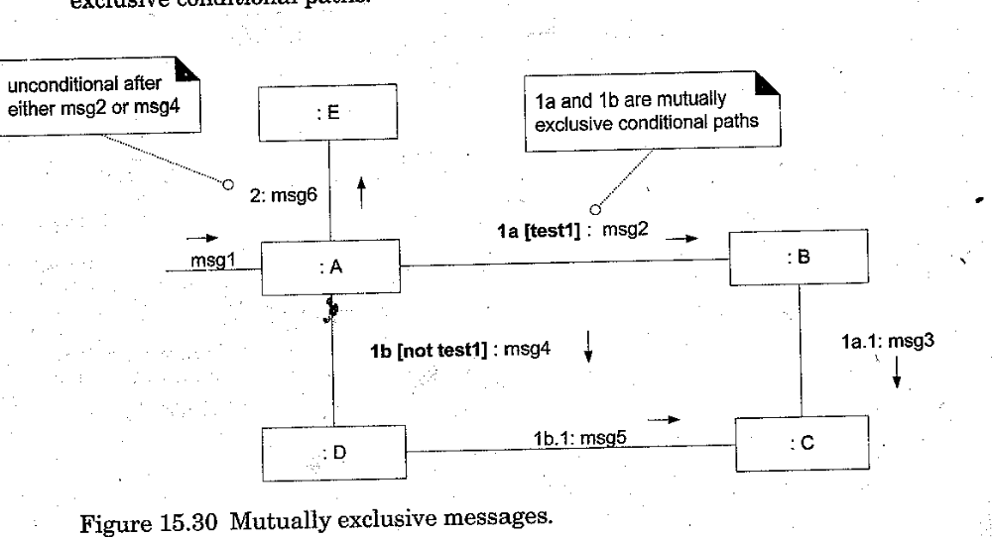

Iteration or looping

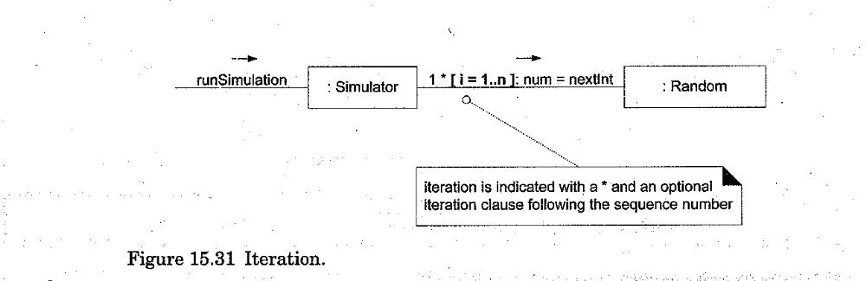

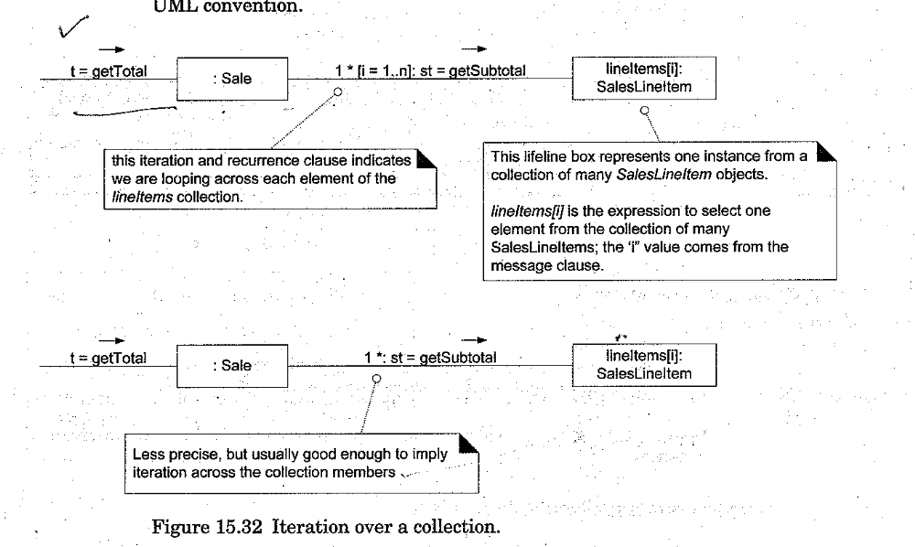

Static class invocation.
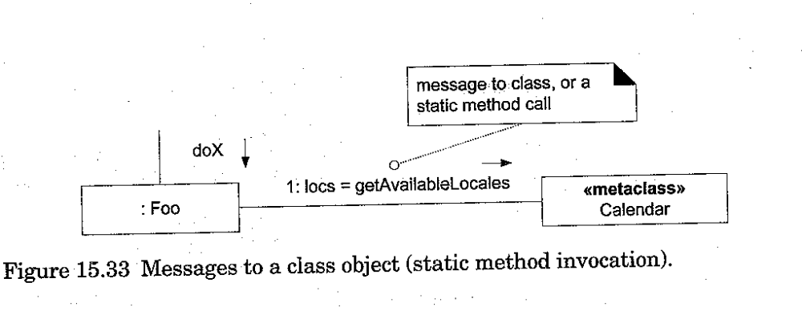

Polymorphic case

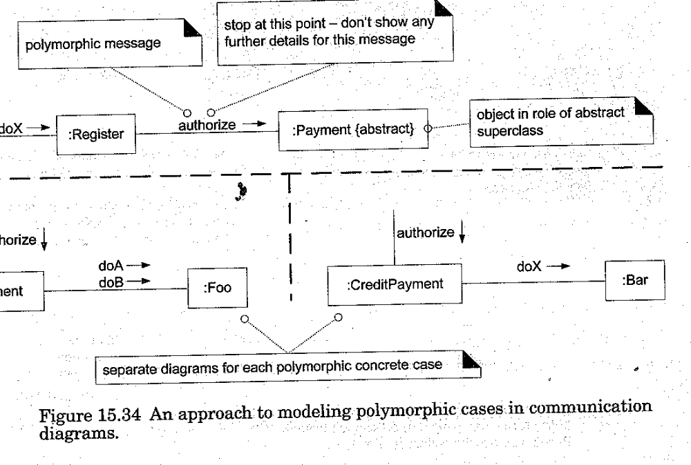
Asychronous Call

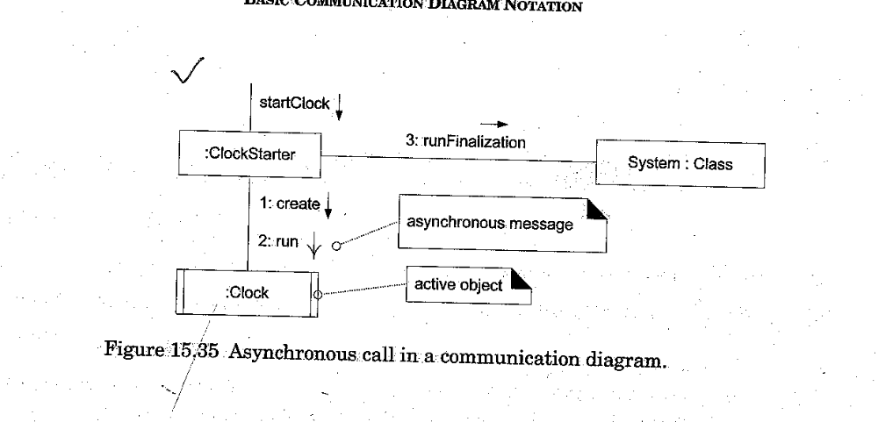

Type | Strengths | Weaknesses
Sequence | Clearly shows sequence or time ordering of  messages  Large set of detailed notation option | Forced to extend to the right when adding new objects.  Consumes horizontal space
 | Space economical flexibility to add new objects in two dimensions | More difficult to see sequence of messages  Fewer notation options

